MAE 469/569: Intro to Astrodynamics
Spring 2026 Project

In this project, you will develop an orbital mechanics code/model to calculate the interplanetary trajectories from Earth to another planet given some parameters. This will be very useful exercise and tool for preliminary interplanetary mission design, and may be something you can talk about for job interviews.

To start, you will need to develop a model of the planet’s motion around the sun in order to track their position at any point in time. Below are the orbital elements for the planets (plus Pluto) at the J2000 epoch, which is January 1, 2000 at 11:58 am UTC (UTC is Coordinated Universal Time, equal to Greenwich Mean Time but not tied to a location on Earth).

Planet | a, AU | eccentricity | i to ecliptic, deg | Ω, deg | ω, deg | θ,deg
Mercury | 0.387099 | 0.205631 | 7.00487 | 48.33167 | 29.12478 | 174.7944
Venus | 0.723332 | 0.006773 | 3.39471 | 76.68069 | 54.85229 | 50.44675
Earth | 1.000000 | 0.01671 | 0.00005 | -11.26064 | 114.20783 | -2.48284
Mars | 1.523662 | 0.093412 | 1.85061 | 49.57854 | 286.4623 | 19.41248
Jupiter | 5.203363 | 0.048393 | 1.3053 | 100.55615 | -85.8023 | 19.55053
Saturn | 9.537070 | 0.054151 | 2.48446 | 113.71504 | -21.2831 | -42.4876
Uranus | 19.19126 | 0.047168 | 0.76986 | 74.22988 | 96.73436 | 142.2679
Neptune | 30.06896 | 0.008586 | 1.76917 | 131.72169 | -86.75034 | 259.9087
Pluto | 39.48169 | 0.248808 | 17.14175 | 110.30347 | 113.76329 | 14.86205

Essentially you need to propagate the planets’ motion forward in time, thus this requires a TOF calculation where the TOF is from J2000 to whatever date and time you are interested in. Once you have a model of the planets’ motion, you can then define the position and velocity vectors of any planet at any time.

Once you know the position vectors, you can then solve Gauss’s problem between any two planet positions and a given TOF to calculate a transfer orbit. This will also give you the heliocentric departure and arrival velocities to then calculate the Phase 1 and 3 Δv’s to do the interplanetary transfers.

Project tasks
MAE 469 students
- Create a planetary motion code/model for all the planets, plus Pluto, and give their true anomalies and heliocentric position and velocity vectors in astronomical units on December 25, 2026 at 11:12 pm UTC. Show this as a table with r and v vectors, and θ for each planet at that time. You must write your own model, do not use any built in function or tool.
- Calculate a trajectory to Jupiter that uses a Mars flyby followed by an Earth flyby. The mission is to launch from Earth in the 2026-2046 time frame. You can pick the launch date and the TOFs.
  - To do this mission, your spacecraft will need to depart Earth on an initial outbound orbit to Mars where it will do a flyby.
  - Next, somewhere after the Mars flyby, the spacecraft will fire its engine in a deep space maneuver (DSM) to change its orbit and redirect itself to where the Earth will be for the second flyby. The second flyby needs to be targeted such that the post-flyby velocity vector puts the spacecraft on an orbit that will intersect Jupiter without additional Δv.
  - So there will only be 3 total Δv here: Earth departure, flyby targeting (DSM), and Jupiter arrival. (This trajectory emulates the Europa Clipper mission trajectory launched in 2024, see the picture below.)
  - Calculate the total Δv (in km/s) required for this mission and the heliocentric positions and velocities of the planets at departure, arrival, and DSM (in astronomical units).
  - Assume the spacecraft is in an initial 500 km altitude circular orbit at Earth and goes into a 10,000 km altitude circular orbit at Jupiter. You can assume the circular orbits at Earth and Jupiter are coplanar to the hyperbolic orbits such that no plane change is required, and the periapsis of the hyperbolic orbit is at the circular orbit altitude.
  - Give the TOF for each leg of the journey. (TOF is not specified here, so it’s up to you to find values that work.)
    - Note: your choice of TOF, launch dates, and flyby hyperbolic turn angles (δ) will change the Δv’s. Have your code draw or plot the planets' orbits and the trajectories of the spacecraft in 3D. This will allow you to see if the code is having your spacecraft do something crazy like an out of plane, which would cost a ton of Δv. You’ll need to show a plot in the report anyways.
    - For 469 students, you don’t need to optimize the trajectory, just calculate one that will work, even if it’s horrendously inefficient (high ΔV).

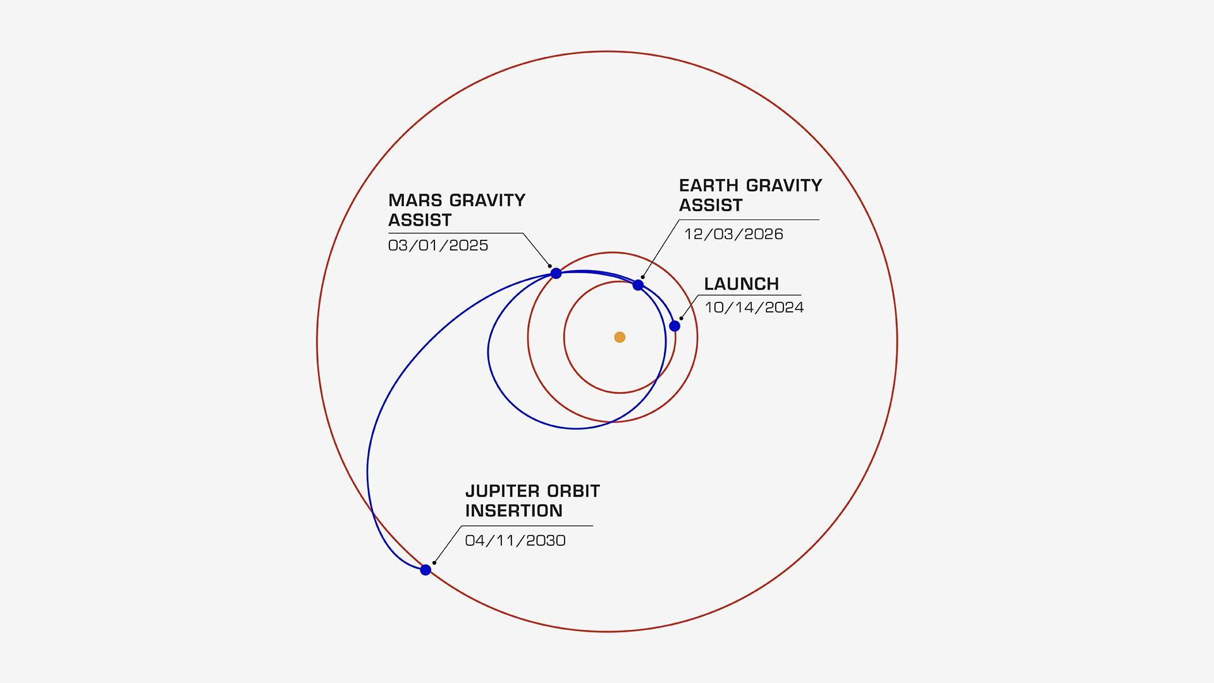
Figure 1. Europa Clipper Trajectory

MAE 569 students
- Everything from the 469 tasks, except you’re not stopping at Jupiter.
- You actually want to go to Neptune by doing an additional Jupiter flyby.
  - So, you’ll do a Mars-Earth-Jupiter flyby to reach Neptune.
  - At Neptune, you’ll be entering into a 2000 km circular orbit.
  - You get two (2) additional Δv’s to use anywhere in the entire mission after Earth departure. So you’ll still have the Earth departure Δv, the DSM Δv, and a Neptune arrival Δv. But, you can use 2 more Δv’s somewhere over the course of the mission. These can be to increase velocity, change direction, or both. You don’t have to use them if you don’t need.
  - The reason for the 2 additional Δv’s is your secondary goal is to optimize the mission by minimizing the total Δv to get to Neptune. It is possible that by making extra small engine burns in deep space, you can reduce the total Δv needed. You don’t have to find an absolute minimum solution, but need to demonstrate that you have explored the possibilities and found a local minima at least.

Project Deliverables
A professional typed report wherein you explain the process used to obtained the results, the requested values, and diagrams and figures as appropriate. Since this is a very math heavy project, the equations used should be included as part of the explanation. Attached the developed code as an appendix to the report. Please upload the completed report to the Canvas assignment and include the last names of all the team members in the file name: MAExxx_project1_name1_name2.pdf

Report Sections
- A title with all team member’s names as subtitle
- An introduction section that explains the problem.
- A methodology section that gives the equations and process used to obtain the results. (Yes, copy/paste or write out the equations for Gauss, TOF, etc.)
- A results section with the following requested information.
  - A table with the position, velocity vector, and true anomaly of the planets on December 25, 2026 at 11:12 pm UTC.
  - A plot of the planets and their orbits on December 25, 2026 at 11:12 pm UTC. Include where the planets are, like with a circle. Have your code plot this to be accurate, and in 3D.
  - The position and velocity vectors of Earth at departure and flyby, and Jupiter at arrival.
  - The orbit elements of the interplanetary trajectories: Earth to Mars, Mars to DSM, DSM to Earth, Earth to Jupiter, etc.
  - The turn angle of the flybys and the pre and post flyby heliocentric velocity vectors.
  - The TOF of each trajectory
  - The ΔV for each engine burn and the total for the mission
  - A plot of the trajectories, similar to the figure one on the previous page. Have the planet orbits be full orbits, not just the portion of the orbit traversed during the TOF. Include markers for the planets at the different events. Have your code plot this to be accurate, and in 3D so you can see if the trajectory makes sense. For this plot, just show the orbits of Earth, Mars, Jupiter, and the spacecraft trajectories.
  - For 569 students, the same information in items b-e but for your longer mission. Be sure to really explain the optimization and lessons learned about the behavior of the trajectory and the additional Δv effects.
- A conclusion of the analysis, and any particular observations about the missions.
- As an appendix, attached your code. Either as printouts or screenshots, or as a separate document in the Canvas submission.

Formatting guidelines
- Times New Roman, Arial, Calibri, or other standard fonts.
- Size 12 for text, minimum 10 for graphs and figures.
- Caption and number all figures.
- Full justify all text, and center figure captions.
- Number all equations
- Number the sections
- Add page numbers to all pages

Grading
Your project will be graded based on the following rubric

Accuracy and realism of the results: 50 pts (breakdown below)
- Planetary code results on specified date: 20 pts
- Plot of interplanetary trajectory (that makes sense): 10 pts
- Trajectory results and delta V’s: 30 pts
Explanation of the process: 30 pts
Formatting and presentation: 10 pts
Above and beyond the requirements: up to +10 pt.
- A common way to try for the bonus points is to optimize the mission for 469 students. By this I mean demonstrate to me an effort to minimize the total Δv expended. This will likely be a series of tables or graphs showing how the various free parameters (TOF, departure date, hyperbolic turn angle, etc.) affect the Δv’s. You don’t need to find an absolute minimum to get bonus. The amount of bonus will depend on how detailed your efforts are.
- For 469 and 569 students, you can try and figure out if your mission could be launched from Earth using existing or in development vehicles. This may include sizing the propellant mass and initial mass of the spacecraft and see how it could fit or if need to be assembled in space. You should come up with your own instruments or payload masses.

